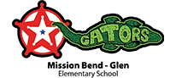

Dear Fort Bend ISD Community, please check your email inbox today for a link to the district’s Culture and Climate Survey.

The survey will help the district identify strengths and areas for growth and guide our efforts to create a positive, supporting environment for both students and staff.

Parents and guardians who have provided their emails to FBISD will receive a direct link to participate in the survey. You can also access it through the QR code provided below.

All FBISD Staff will receive a direct link to participate in the survey via their district email.

The email will contain a link to complete the survey using our new stakeholder engagement tool, Qualtrics. The survey will be open through May 12.

We value your insight into our schools and district.

Sincerely,

Fort Bend ISD Administration

